**PERCENTILE**

* Percentile is a measure thet tells the value below which a certain percentage of data falls.
* Here the percentile is represented as quadrants Q1,Q2,Q3 and Q4.
* Table shown below is a placement data percentages of student marks under 25%,50%,75% and 100%.

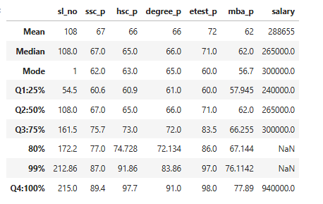

* Tables would be plotted as graphs for easy analysing and understanding.

**Differences between each quadrants:**

Q1~ Q2 = 6.4

Q2~ Q3 = 8.7

Q3 ~ 99% = 11.3

Q3~ Q4 = 13.7

99% ~ 100% = 2.4

**Differences between each quadrants:**

Q1~ Q2 = 4.1

Q2~ Q3 = 8

Q3 ~ 99% = 18.8

Q3 ~ Q4 = 24.7

99% ~ 100% = 5.8

**Differences between each quadrants:**

Q1~ Q2 = 5

Q2~ Q3 = 6

Q3 ~ 99% = 11.8

Q3 ~ Q4 = 19

99% ~ 100% = 7.2

**Differences between each quadrants:**

Q1~ Q2 = 11

Q2~ Q3 = 12

Q3 ~ 99% = 14

Q3 ~ Q4 = 15

99% ~ 100% = 1 Nearly the same

**Differences between each quadrants:**

Q1~ Q2 = 4.1

Q2~ Q3 = 4

Q3 ~ 99% = 10

Q3 ~ Q4 = 11.8

99% ~ 100% = 1.8

**Differences between each quadrants:**

Q1~ Q2 = 25000

Q2~ Q3 = 35000

Q3 ~ Q4 = 64000

**INTER QUARTILE RANGE (IQR)**

* IQR is used to replace the acceptable values for outlier values.
* The purpose of IQR is to know the outlier range present in the dataset.

IQR = Q3 – Q1

* Lesser Outlier = Q1- 1.5(IQR)
* Greater Outlier = Q3 + 1.5(IQR)
* Why 1.5 factor is chosen?
* 1.5 IQR is a Rule of Thump declared by John Tuckey.
  + IQR is less sensitive to skewed data distributions, as it is based on percentiles.
  + 1.5 multiplier determines the width of the outlier detection boundaries.
  + A large multiplier would make the fence wider considers more points as valid points and potentially missing genuine outlier.
  + A smaller multiplier would make the fence narrower, potentially labeling the valid extreme data points as outlier, which is undesirable.
* IQR Question to find 5 values in day and night.

1) Dataset

|  |  |  |  |  |  |
| --- | --- | --- | --- | --- | --- |
|  | Min | Q1 | Median | Q3 | Max |
| Day | 32 | 56 | 74.5 | 82.5 | 99 |
| Night | 25.5 | 78 | 81 | 89 | 98 |

Solution:

Totally 5 Values.

Day - 32,56,74.5,82.5,99

Night – 25.5,78,81,89,98